**AIM:** To perform **White-Box Testing** to test the functionalities and perform **Black-Box Testing** on a test case template for the system.

**THEORY:** White box testing aims to verify the correctness of the internal code, identify logical errors, and ensure that all code paths are tested. Black box testing aims to validate the software's functionality, ensure it meets the specified requirements, and assess how it behaves from an end-user perspective.

**WHITE BOX TESTING:**

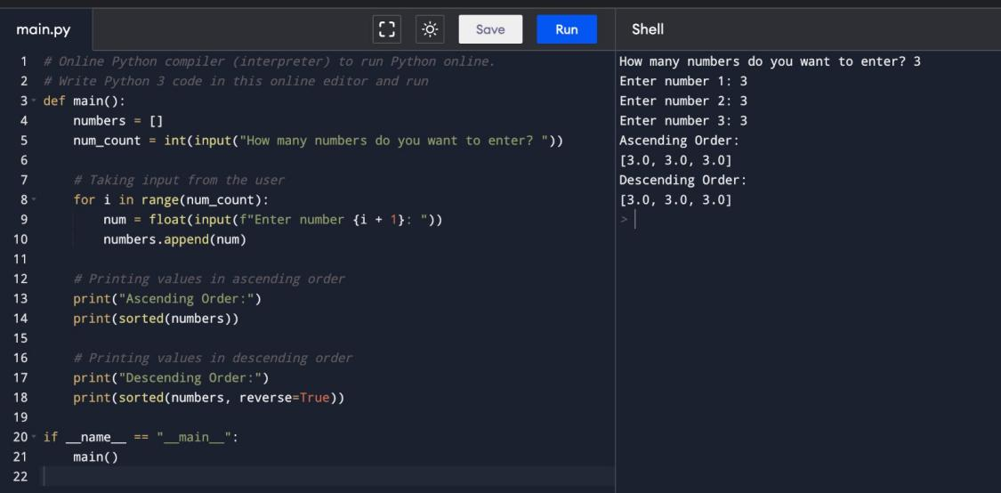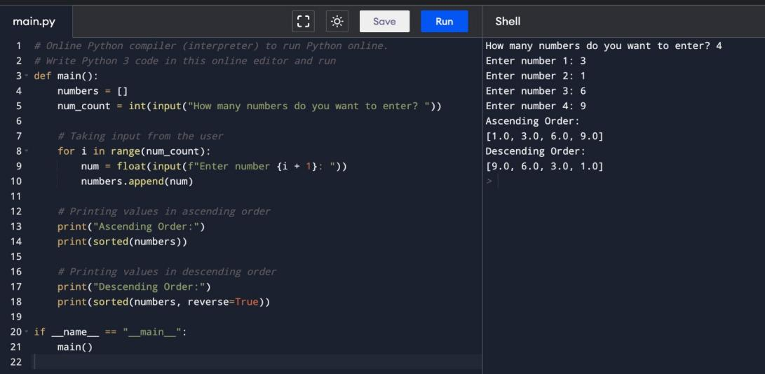

**BLACKBOX TESTING:**

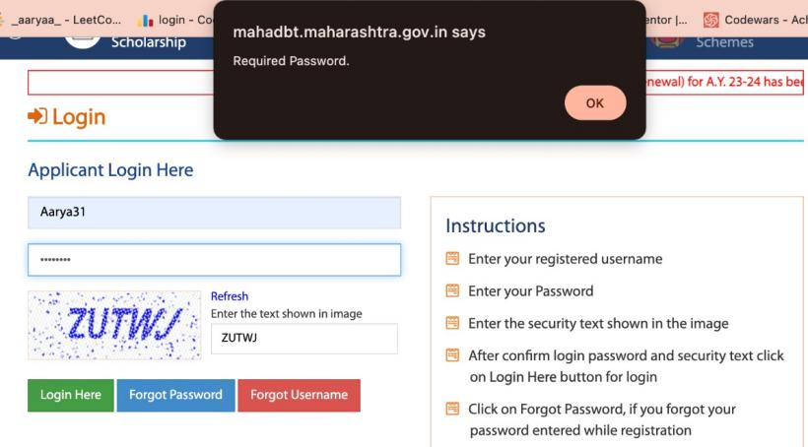

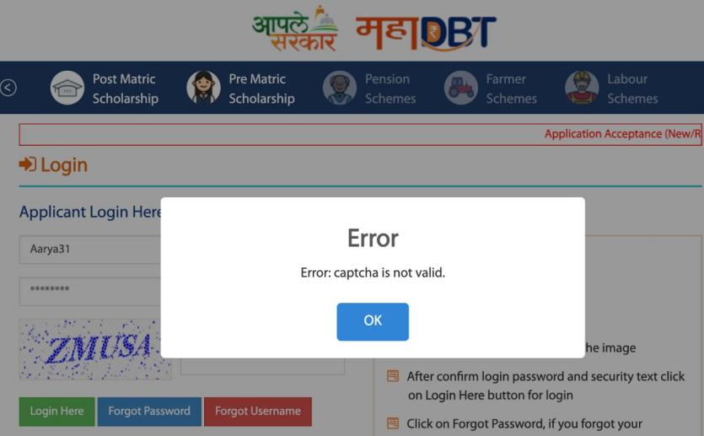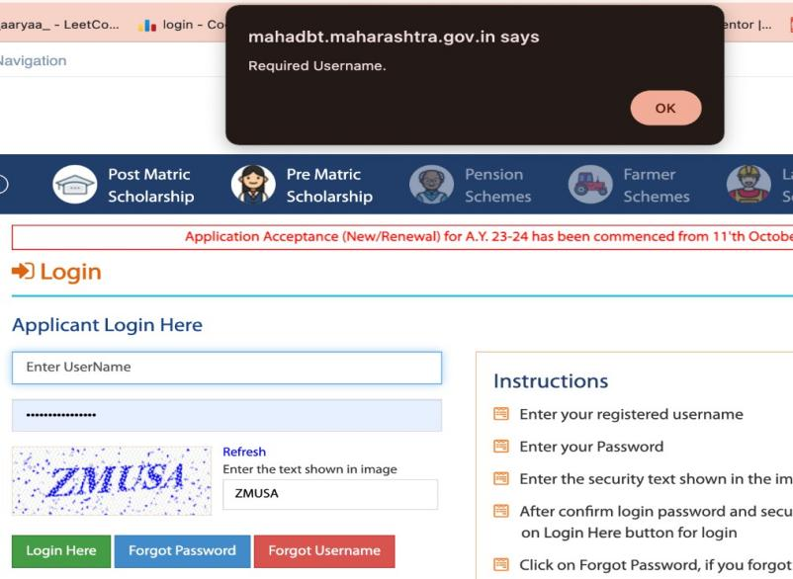

**ANALYSIS BY TESTER:**

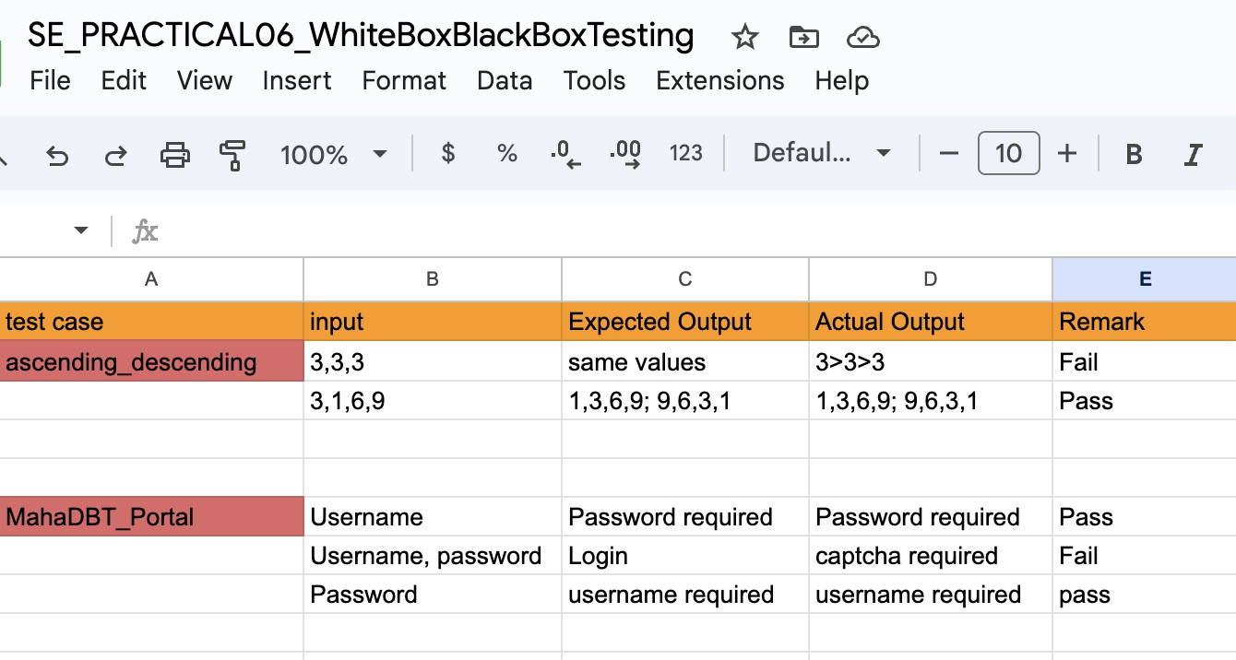

**CONCLUSION:** In this practical, we gained experience in executing both White Box and Black Box Testing techniques.